Sample program flow.

After starting the program, the Menu is displayed. We can choose from 6 options and Quit. It is worth noting that the program automatically loads the previously saved list.

Choosing the first one will lead us through the process of creating and adding a new client to the list. The data is automatically calculated, validated and formatted, only the results of these operations are stored in the object.

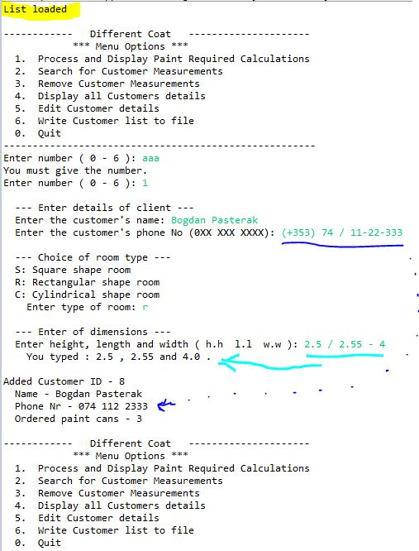

Options 2 and 3 are very similar in operation. The difference is that option 2 prints only data about the selected client, option 3 removes it from the list.

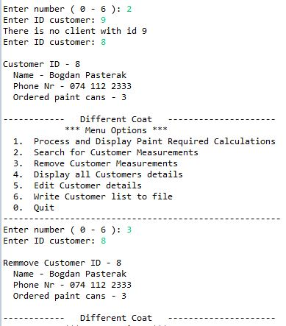

Option 4 prints the entire list.

Option 5 added outside of the requirements seems to me necessary because I was here. You can edit it from the client list. Each element can be left unchanged by pressing Enter.

In the following example, only the name and telephone number have been changed. Paint calculations were left unchanged.

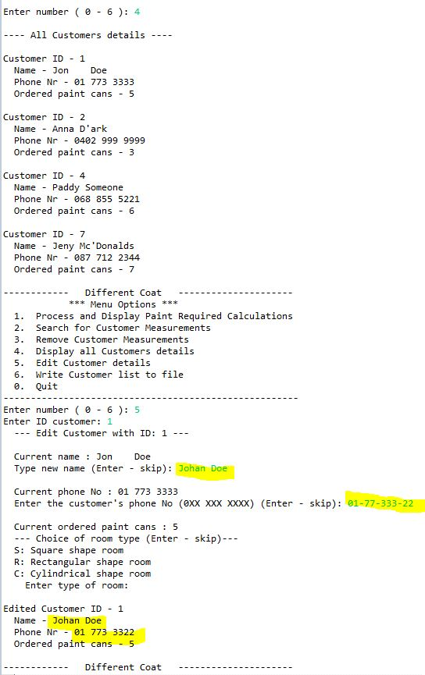

Option 6 saves data to a file. The corresponding message is displayed.

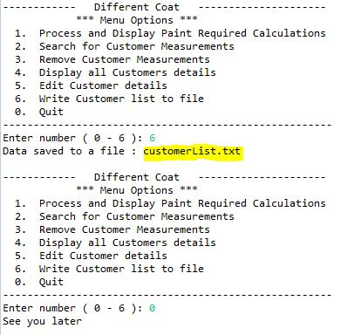

At the end (option 0) the program says goodbye to us.

It is worth noting that the data stored in the file are public, legible and easy to edit.

